ONLINE FOOD ORDERING SYSTEM

DETAILED SYSTEM ARCHITECTURE REPORT

1. Introduction
System Architecture describes the structural framework of the Online Food Ordering System.
It explains how hardware, software, network components, and databases interact to deliver
food ordering services to customers, restaurants, and administrators efficiently.

The architecture ensures scalability, security, maintainability, and high system performance.

2. Architecture Overview
The system is designed using a Three‑Tier Architecture Model which separates the system into:

• Presentation Layer (Frontend)
• Application Layer (Backend)
• Data Layer (Database)

This separation allows independent development, easier maintenance, and improved security.

3. Presentation Layer (Frontend)

This layer represents the user interface where all users interact with the system.

Main Users:
• Customers
• Restaurant Staff
• Administrators

Features:
• User registration & login
• Restaurant browsing
• Menu viewing
• Cart management
• Checkout process
• Order tracking dashboards

Technologies Used:
• HTML5
• CSS3
• JavaScript

Responsibilities:
• Display system data
• Capture user inputs
• Send requests to backend APIs
• Show responses such as order status and confirmations

4. Application Layer (Backend)

This is the core processing layer (system brain). It handles business logic and decision making.

Components:
• Web server
• Application server
• RESTful APIs
• Authentication services

Key Functions:
• User authentication & authorization
• Order processing workflow
• Restaurant menu management
• Payment processing integration
• Notification triggering
• Admin control operations

Technologies:
• PHP (Laravel)

5. Database Layer (Data Layer)

This layer manages persistent data storage.

Database Systems:
• MySQL
• PostgreSQL

Stored Data Includes:
• Users
• Restaurants
• Menu items
• Orders
• Order details
• Payments
• Deliveries
• Reviews

Responsibilities:
• Data storage & retrieval
• Data integrity enforcement
• Backup & recovery
• Transaction management

6. System Components Architecture

6.1 Client Devices
Includes browsers and mobile devices used by customers and admins to access the system.

6.2 Web Server
Handles HTTP/HTTPS requests and serves static content.
Examples: Apache, Nginx

6.3 Application Server
Executes business logic, processes orders, and communicates with the database.

6.4 Payment Gateway Integration
External APIs integrated for secure payments such as:
• Stripe
• PayPal
• Mobile Money (M‑Pesa, Airtel Money, Tigo Pesa)

6.5 Notification Services
Used to send alerts via:
• Email
• SMS
• Push notifications

7. Deployment Architecture

The system can be deployed in two environments:

7.1 Local Deployment
• XAMPP / WAMP / LAMP
• Used for development & testing

7.2 Cloud Deployment
• AWS for hosting
• Google Cloud

Benefits:
• High availability
• Remote accessibility
• Scalability

8. Security Architecture

Security mechanisms implemented include:

• SSL/HTTPS encryption
• Password hashing
• Role‑based access control
• Secure payment gateways
• Firewall & server protection

9. Scalability & Performance Considerations

To support many users simultaneously:

• Load balancing
• Database indexing
• Caching (Redis)
• CDN for images & static files

10. Advantages of the Architecture

• Modular design
• Easy maintenance
• High scalability
• Improved security
• Faster system performance

11. Future Architectural Enhancements

• Microservices architecture
• Mobile application integration
• AI food recommendation engine
• Real‑time GPS delivery tracking

12. System Architecture Diagram
The diagram below illustrates how clients interact with the frontend, backend,
and database layers of the Online Food Ordering System.
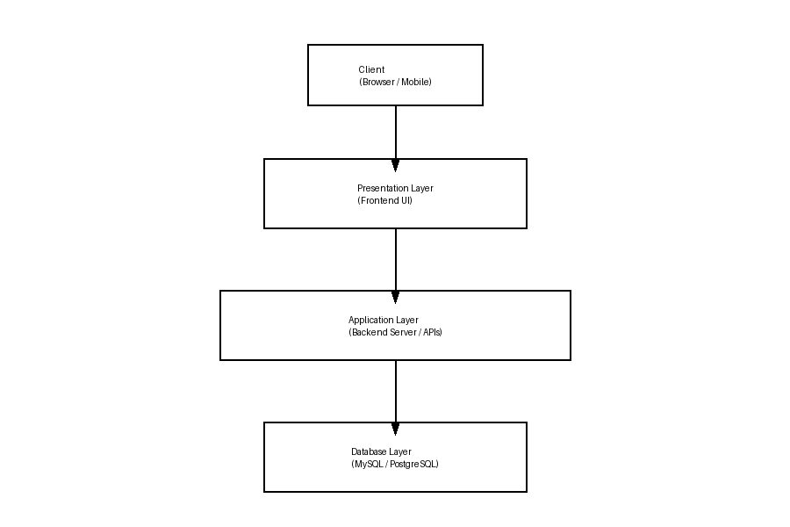
Figure: Online Food Ordering System Architecture Diagram

